**Build steps[ We will create below jobs manually and run them]**

**At the end of the document, as a part of package job, .war file will be created**

**Jobs : Compile 🡪Code review🡪Unit Test🡪Code coverage**

**Pre-Requisite :**

1. Created Ubuntu instance from AWS console
2. Installed Jenkins, Java, Maven on this machine
3. Launch Jenkins using public of the Ubuntu instance created with 8080 port number
4. Configure Git, JAVA and Maven under, Global tool configuration and Plugins : pmd, build pipeline, coberturra from Manage Jenkins section
5. Create “Compile job”(Note : Other 2 are practice jobs. Please ignore them)
6. This job used git repository in the source code management, Build Trigger : POLL SCM with ***** trigger every 1 min
7. Under Build option, provide MAVEN command : compile

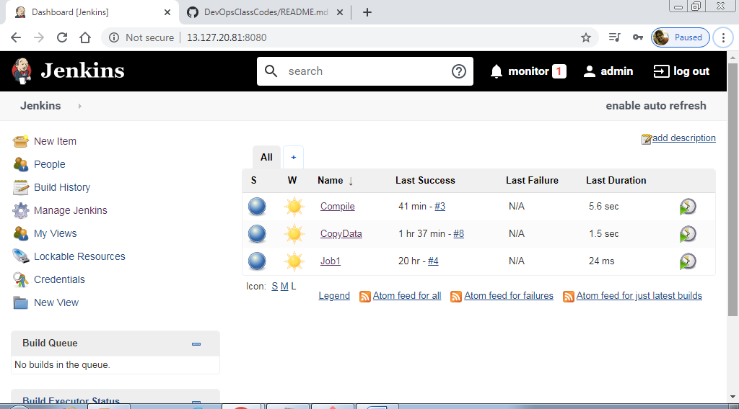

**Compile folder created**

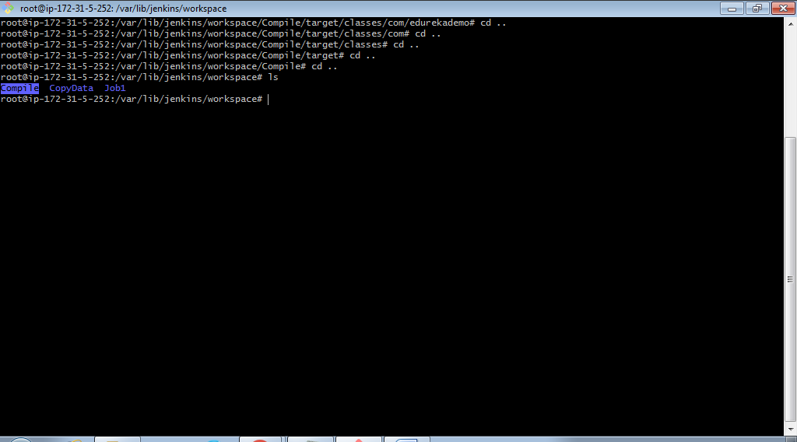

**Target also created after job is run**

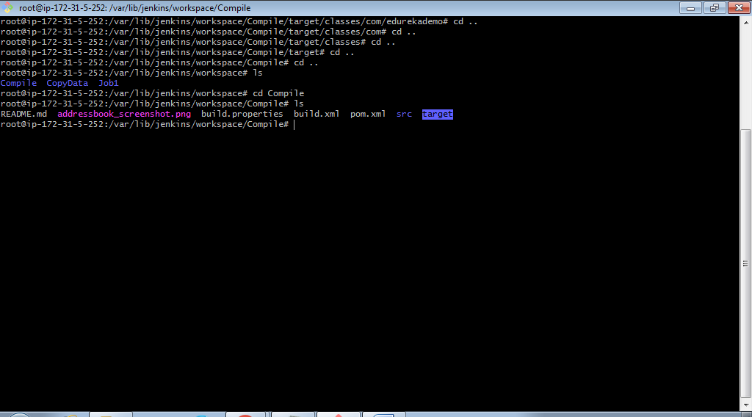

**As a result of Compile – classes folder gets created**

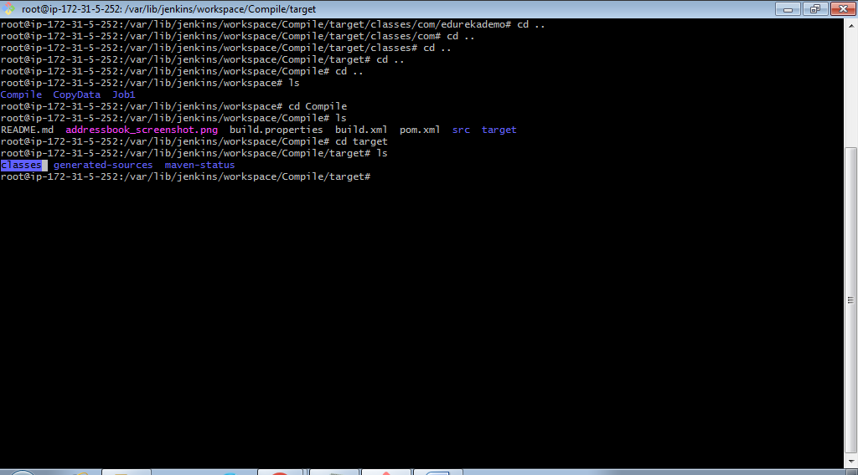

**Now, create the 2nd job for code review**

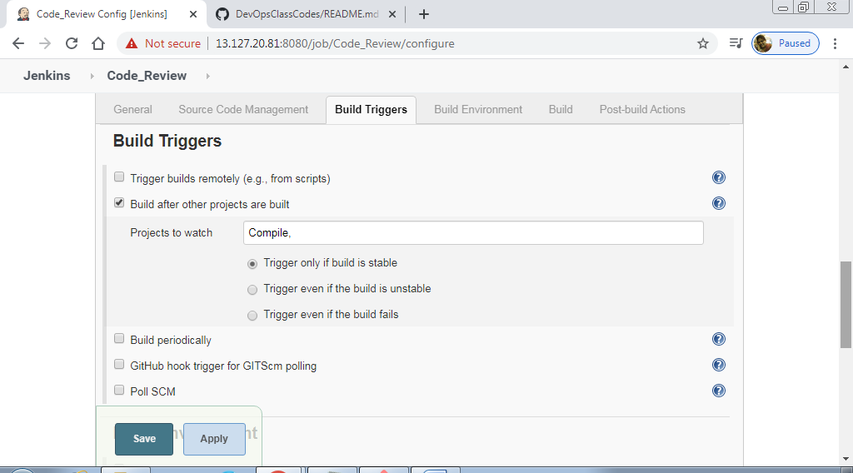

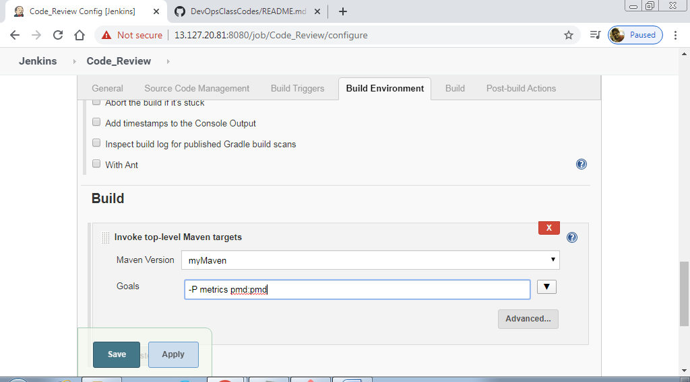

**Code_Review : Success**

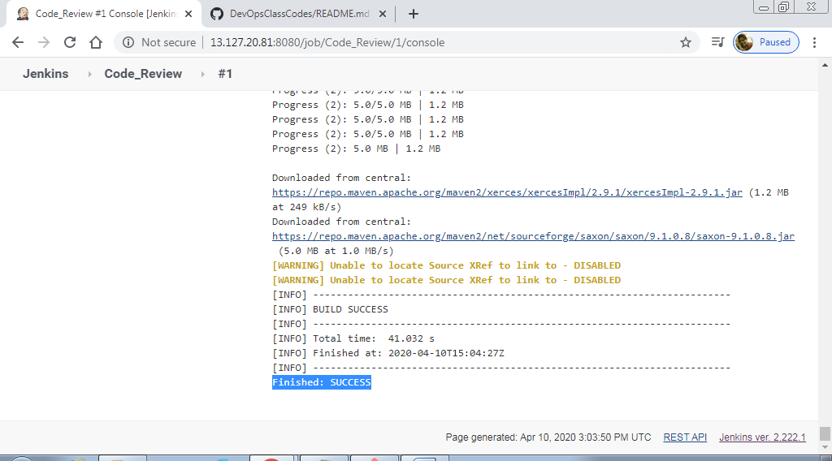

**As an output – pmd.xml is created**

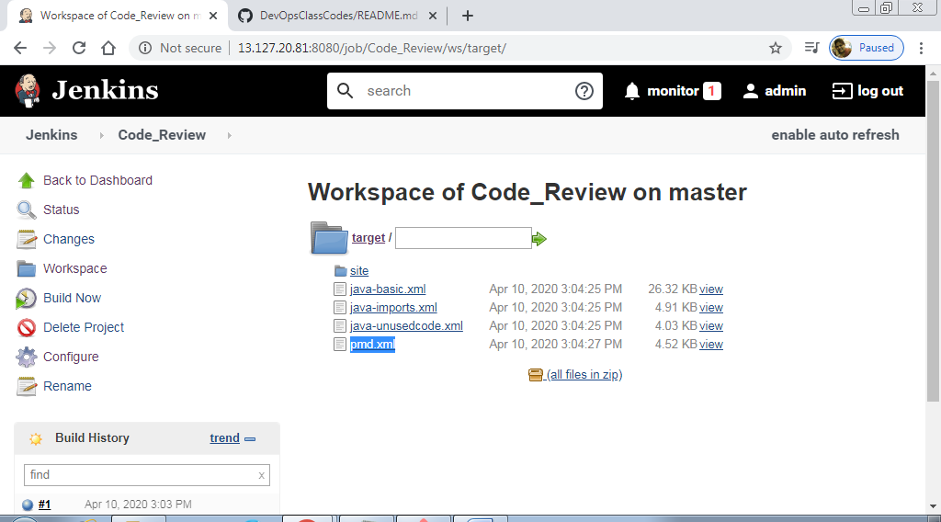

**Xml to html coversion**

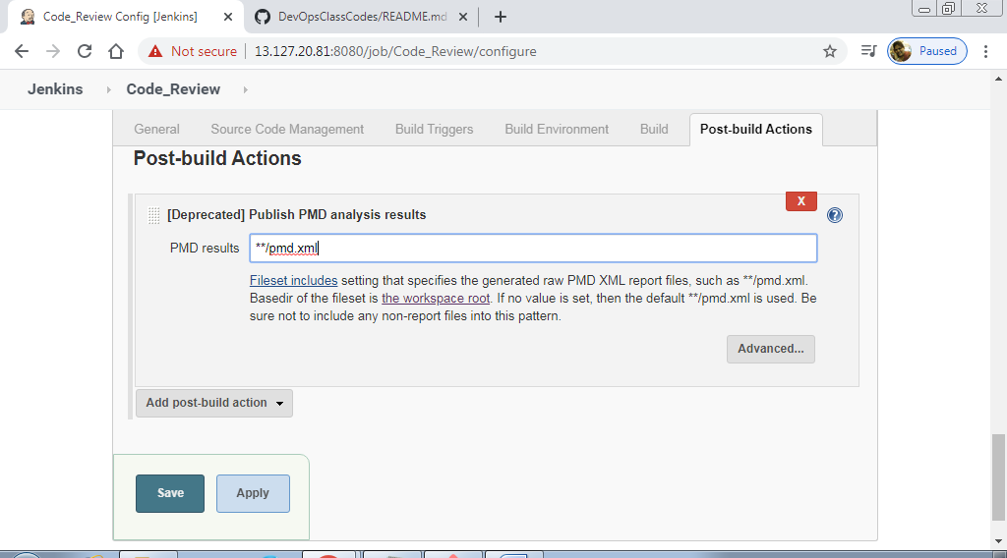

**Save and trigger the build again**

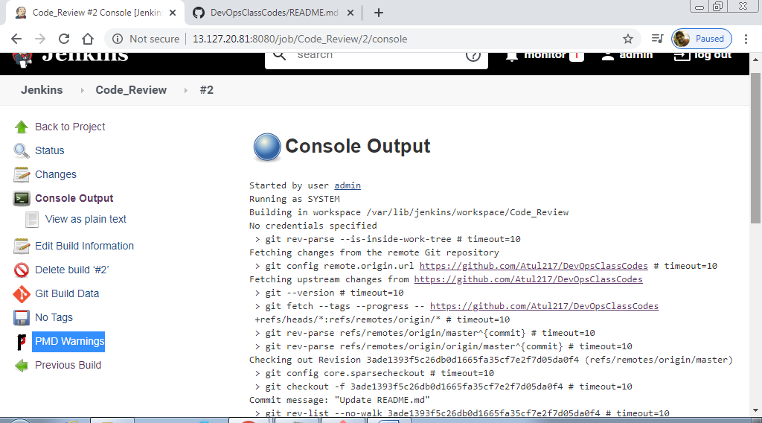

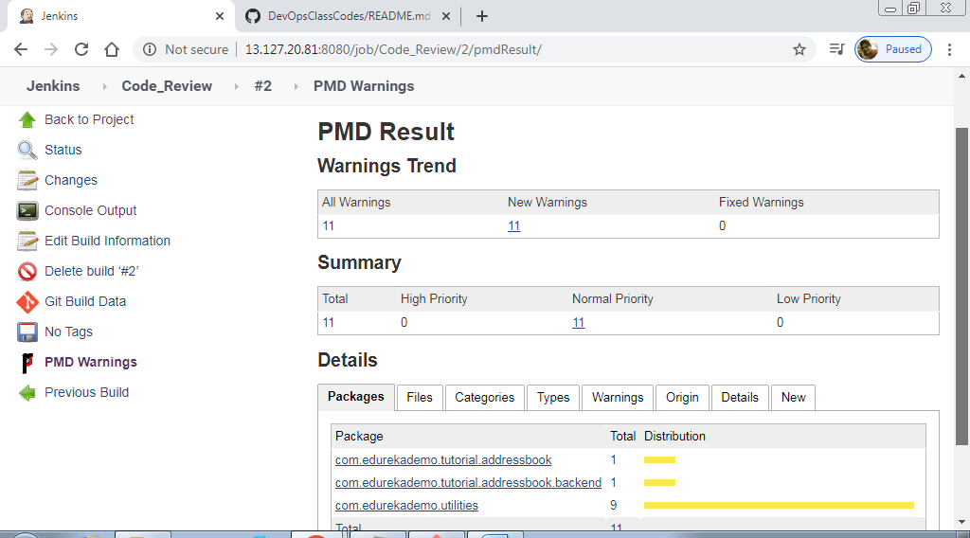

**Now 3rd job for Unit Test**

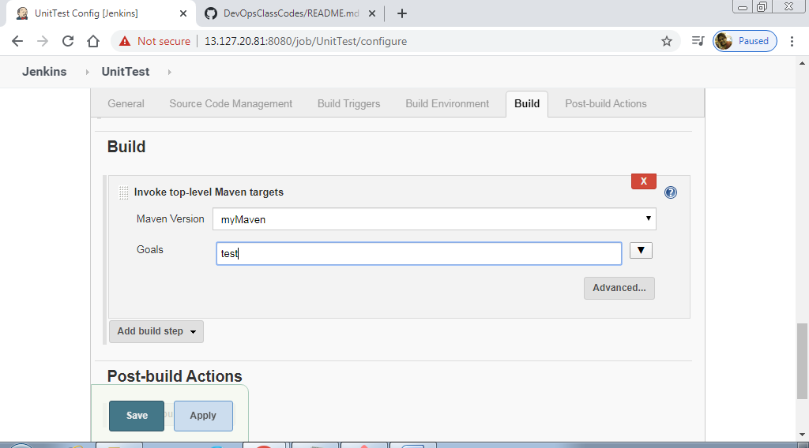

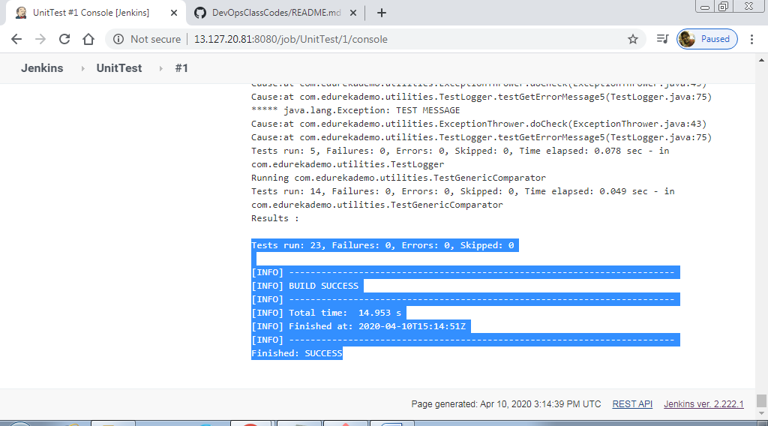

**Sure-Fire plugin(This is configured by Developer/Tester under Maven🡪pom.xml file)**

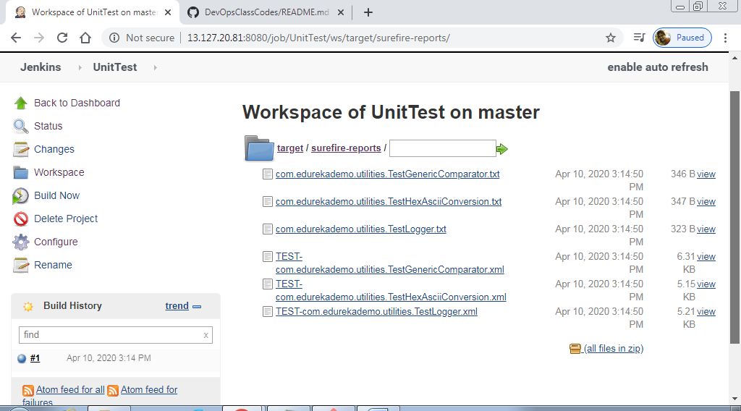

**Again xml to html conversion**

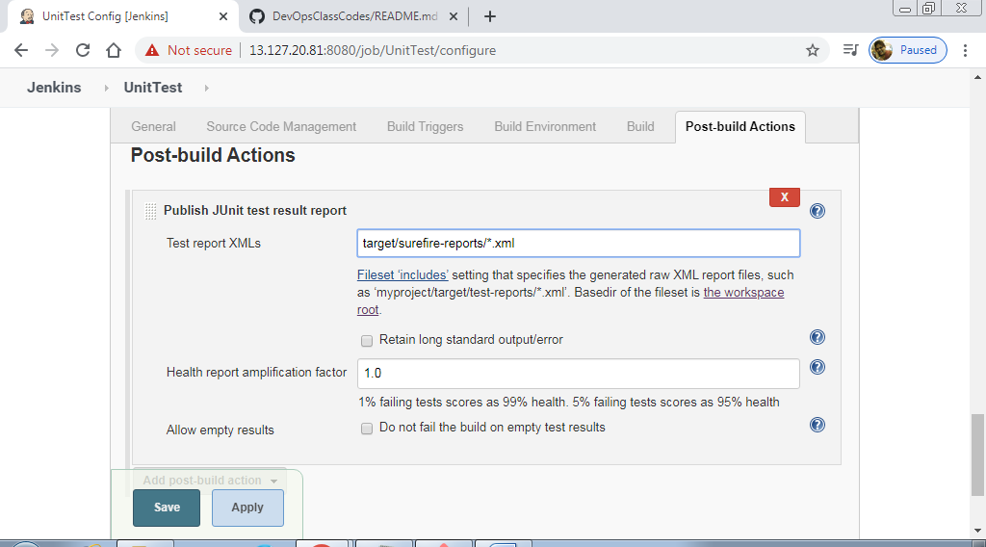

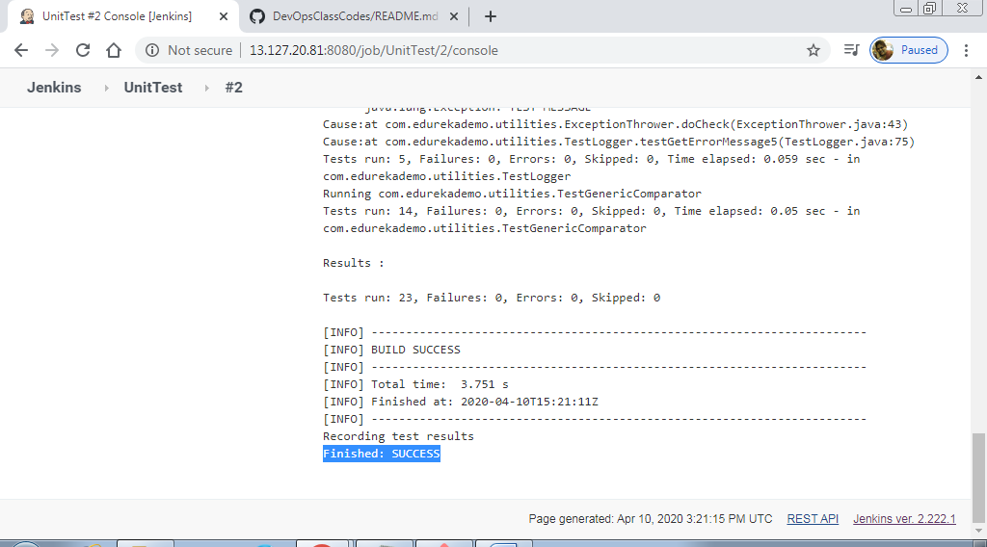

**On the job page, you have latest results**

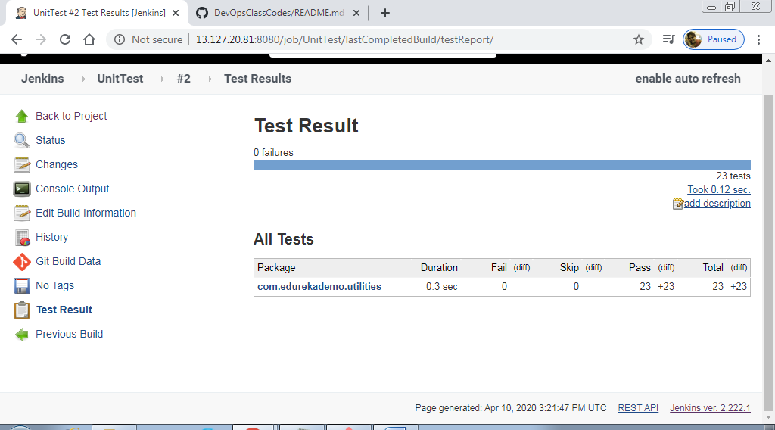

**After UnitTest , Create Code Coverage job**

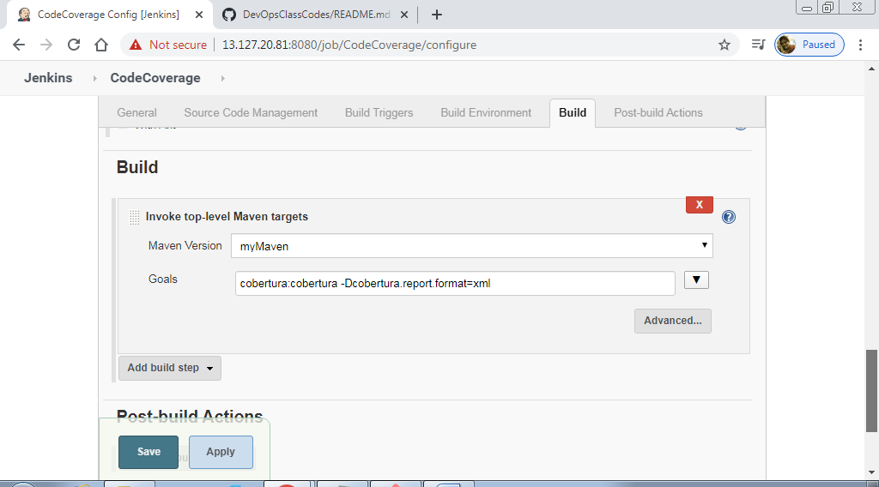

**Downloaded cobertura online using pom.xml file**

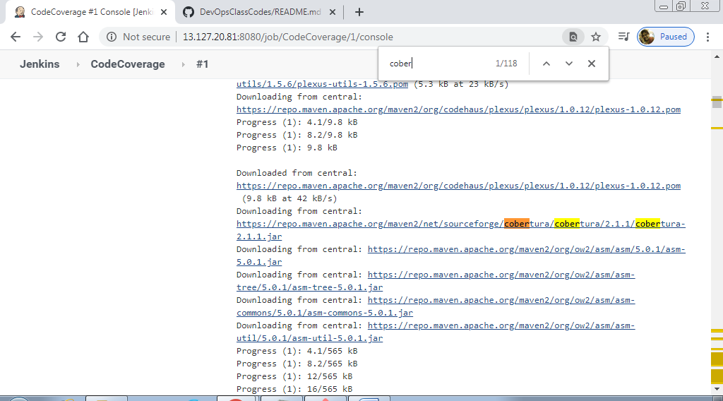

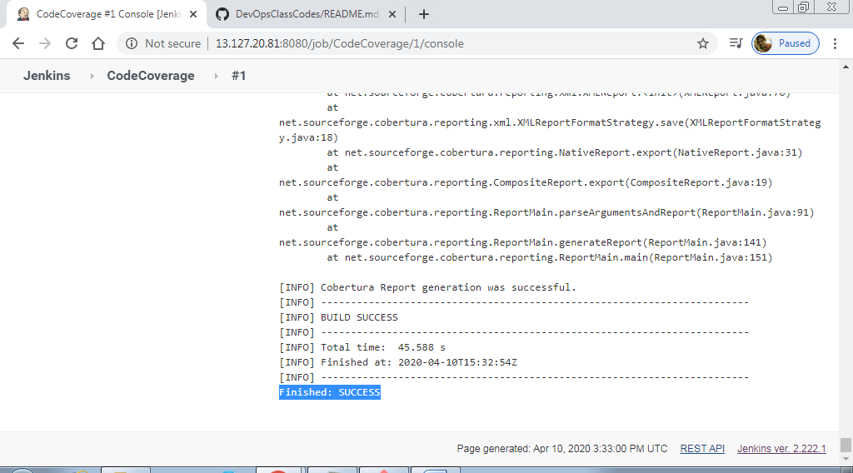

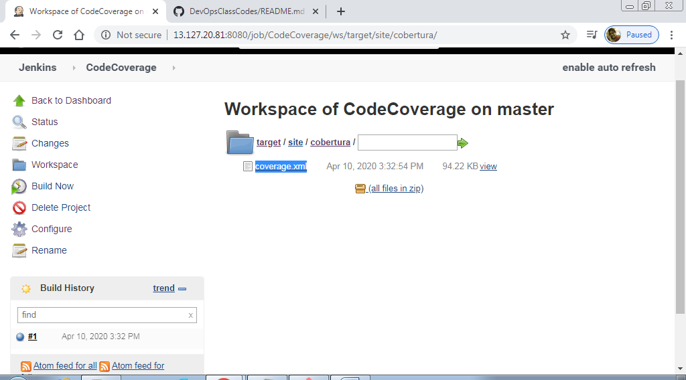

**Xml file**

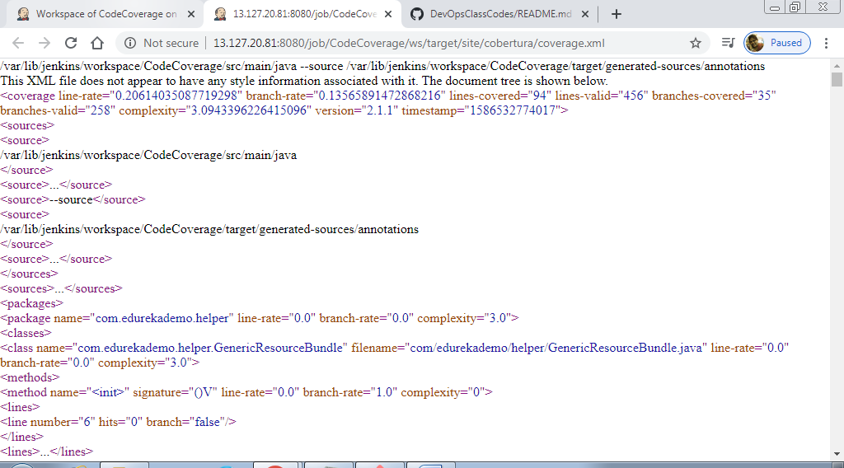

**Covert file to html**

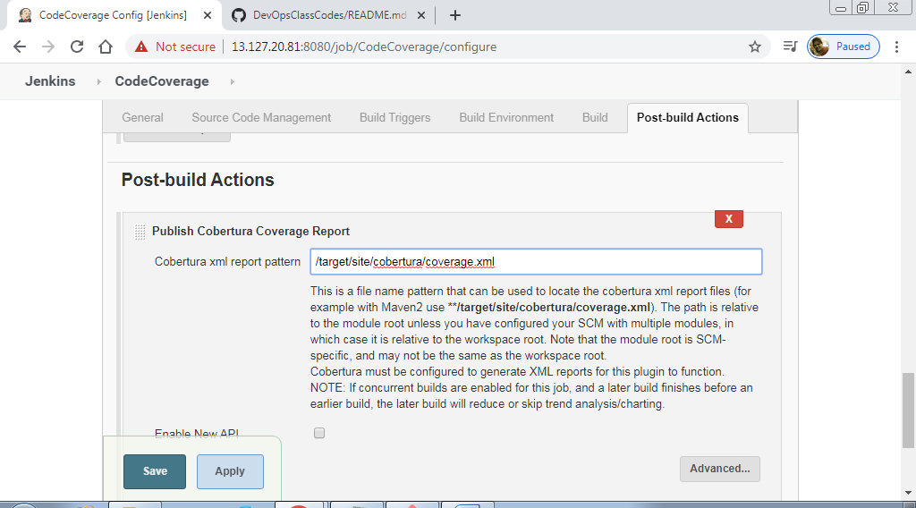

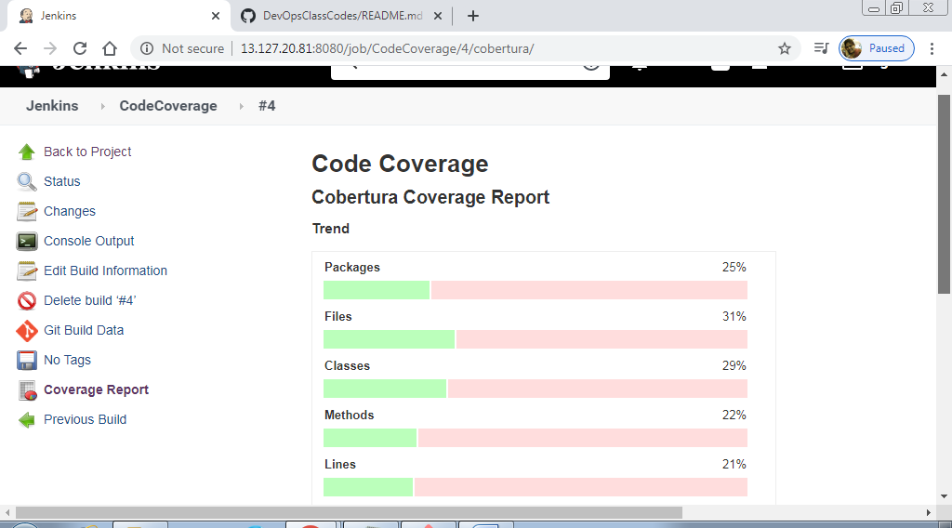

**Create the last job : Package**

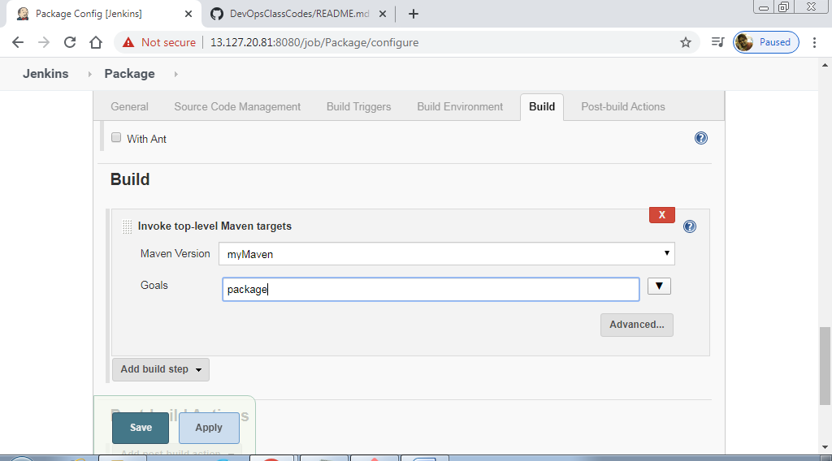

**Trigger the job**

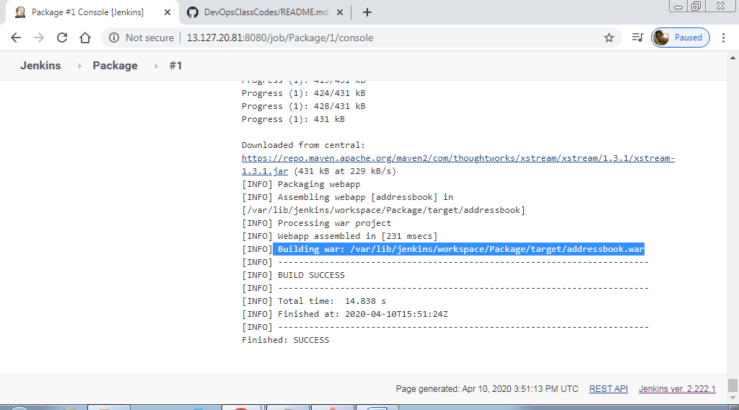

**It will compile the previous goal, that is the inbuilt behavior of Maven**

**Even if you create only package, it will run all the steps before**

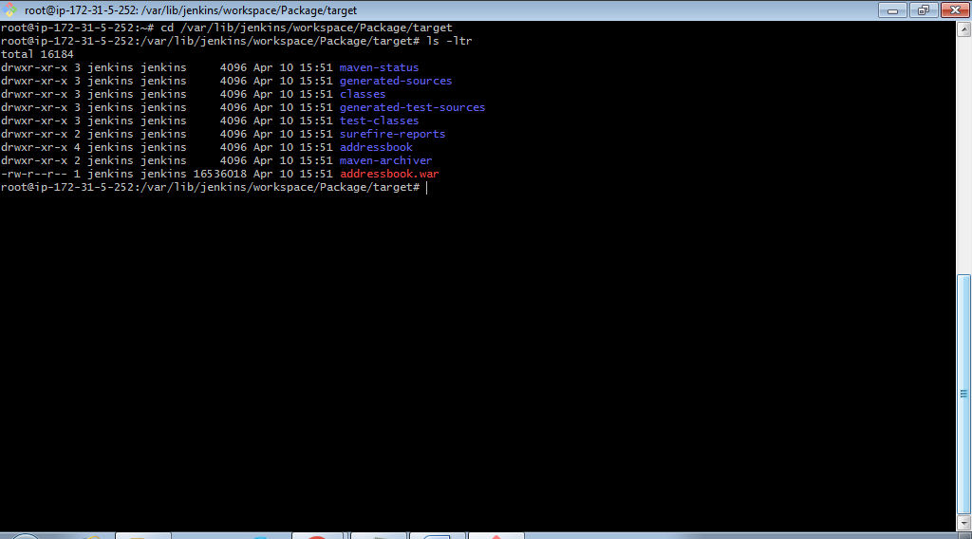

**There is 1 more command, maven install. If we run this, then it just copies the file from this location to default maven location**

